5 Simple Steps to Drawing Op Art Hands
In this post I’ll show you 5 simple steps illustrating how to draw op art hands that will have impressive results. This project is a fun way to introduce students to Optical Art (Op Art) and the result is a cool looking optical illusion that gives the impression that the hand is popping off the paper. And the best part about it is that it is really easy to do. I mean what can be easier than tracing your hand!
I did this lesson with my 6th grade students, but it could easily be done with both older and younger students. There are many variations possible for the lesson. I used it as a fun way to teach color theory with the use of warm or cool colors.

History of Optical Art
Optical Art, better known as Op Art, is an abstract style of art that creates an optical illusion. The art movement became popular in the 1960’s by Bridget Riley and Victor Vasarely. They used patterns and colors to disorient the viewer.

* Some of the links in this post may be affiliate links. This means I receive small commissions for purchases made through these links at no extra cost to you.

Art Supplies
Paper (large enough to fit hand with a bit extra around the edges)
Pencil
Thin black marker
Colored pencils
Kneaded eraser

The Method

Step 1
Lightly trace your hand using a pencil. You do not want the original outline of your hand to show when finished so trace as lightly as possible. When you are tracing around your fingers make sure you are not making them too thin. If your fingers are too thin it will make it more difficult to add your lines in the next step. This was one of the common struggles my students had when completing this step.
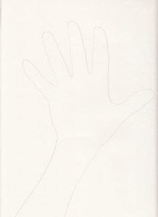

Step 2
Begin adding your lines with a thin black sharpie or other type of thin marker. It seems to be easiest to start at the bottom of the page. Begin where your arm is and draw a curved line on the arm and then straight lines for the background. It may be easier to have students start by using a pencil for the first four or five lines until they got the hang of it, then using the marker to add the rest.
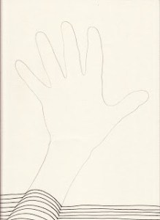

Tips:
- Make sure your straight lines for the background meet where the curved lines of the arm and hands are
- Do not trace your outline of your hand and arm with the black marker
- If there is too much space between your lines it will not look like the hand is popping off the page. Be sure to place your lines fairly close together

Step 3
Continue adding lines and moving up the paper towards the top of the page. When doing the fingers I found it was easier to curve your lines in the opposite direction instead of trying to add straight lines there. If you look at the example below, the lines in the fingers curve up and the lines in between the fingers curve down.
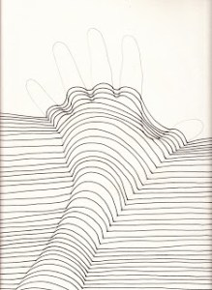

Step 4
The most difficult part of this project is ending the fingers. It’s a bit of a struggle to find a way to get back to straight lines at the top once you get past the finger tips. You don’t want the curves at the top of the page to exactly match the curves on and around your fingers. Try to flatten out your lines as much as possible so it won’t look like your fingers continue past the point where they should end.
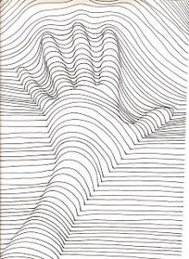

Step 5
Choose three colors, using a color scheme, and color between your black lines using colored pencils. For this lesson, I used a monochromatic color scheme for my example. I also gradated my colors to help the hand pop off the page. Finish by using a kneaded eraser to lift some of the color off the ridges of the fingers, hand, and arm.
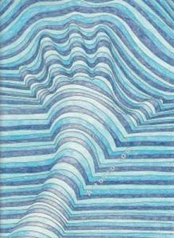
I hope you enjoyed this step by step lesson showing you how to draw op art hands in 5 simple steps.
Did you find this tutorial useful? Feel free to share it with your friends on Twitter, Instagram, or Facebook using the share buttons.

